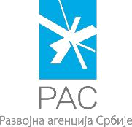
FORM 3

SUPPORT PROGRAM FOR BUSINESS START-UPS – START UP PROGRAM
_________________________________________________________________________

STATEMENT

I ,
(Applicant’s name and surname)

am an Applicant within the Support program for business start-ups
– START-UP PROGRAM and I declare under penalty:

that in previous 12 months I did not have a registered business activity nor a share of more than 50% in the ownership structure of a business entity.

Otherwise, I agree that the submitted application be refused.

In _____________________ | Applicant's Signature
Date: ________________ | _________________________

Belgrade, Kneza Miloša 12 е-mail: startup@ras.gov.rs www.ras.gov.rs

